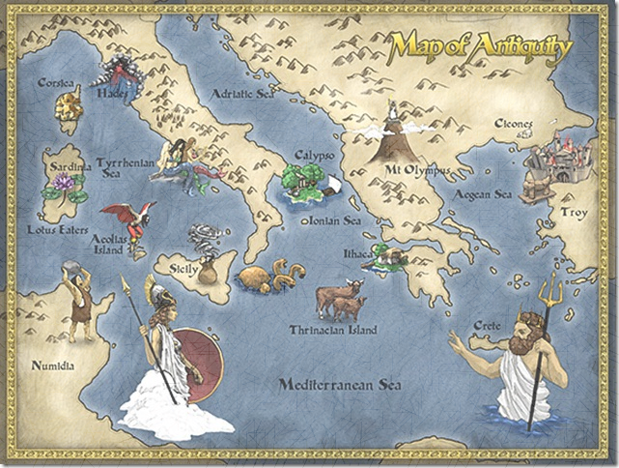
Odyssey 2014 Packet

In the Beginning…
In the beginning, all was nothingness. Some say the nothingness was noisy chaos, and others suggest that all was silent. Although no one could say how or when, the nothingness became light, and day was followed by night. Then came love. With love, Mother Earth (Gaea) and Father Heaven (Uranus) came into being. Because of their love, they had many children. They had two kinds of children: Titan children and monster children. The Titan children were enormous, strong, and beautiful. The monster children were ugly and frightening.
Uranus disliked his monster children and locked them underground in the darkest part of the earth. However, Gaea was heartbroken and asked her youngest son, Cronus, who was one of the Titans, to rescue them. He agreed. To thank him for his help, Mother Earth gave her son Cronus and his sister Rhea, who was also a Titan, rule of heaven and earth.
Cronus and Rhea married each other and had six children. Each time Rhea presented Cronus with a child, however, he swallowed it. Rhea was horrified. When her sixth child was born, she wrapped a rock in a blanket instead of the baby and presented it to Cronus. He swallowed the rock, believing it to be the baby. Rhea then sent her sixth child, Zeus, to the island of Crete to be raised. Once Zeus had grown up, he and Rhea fought against Cronus to make him vomit the five swallowed children, now fully grown.
Zeus divided the world among himself, his brothers (Hades and Poseidon), and his sisters (Hestia, Demeter, and Hera). Thus began the final generation of rule by the Olympians.
Olympian Family Tree
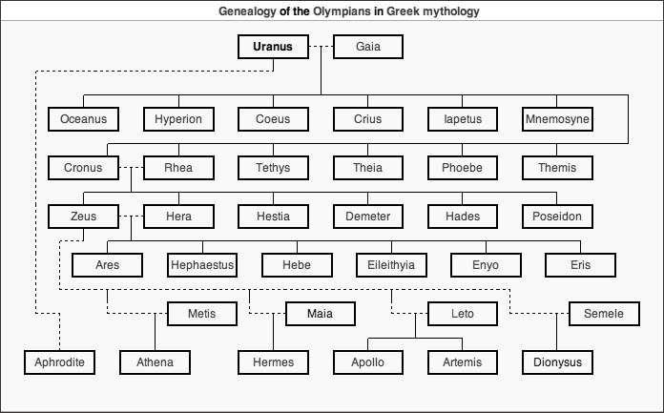

The Pantheon
Major Greek Gods

Gods & Goddesses to notice in the Odyssey:

- Zeus because he helps Odysseus several times.
- Athena because she helps Odysseus and enjoys the fact that he uses his brain over his brawn.
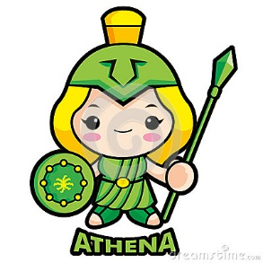
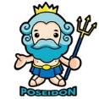
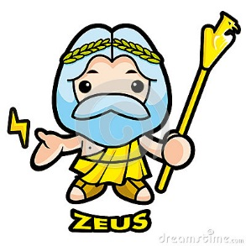
- Poseidon because he is seeking revenge on Odysseus.
The Odyssey Reading Guide

Tell the Story
- Who is speaking in this opening scene?

- What is a muse?

- What happened in Troy?

- Where is Odysseus, the "contender," trying to go?

- Which god is plotting against Odysseus?

PART ONE: THE WANDERINGS PART ONE: THE WANDERINGS

Calypso, the Sweet Nymph
- How long did the Trojan War last?

- How many years has Odysseus spent trying to return home?

- Who is Calypso and what is her relationship to Odysseus?

9. Who is narrating the story?

10. Who is Hermes and what is his mission?

11. Of whom is Calypso seemingly jealous?

12. How does Odysseus regard his wife Penelope?

13. How does Calypso assist Odysseus on his journey home?

"I am Laertes' son...."
14. What tragedy strikes Odysseus at sea?

15. How is Odysseus received on the island of Scheria, home of King Alcinous?

16. Describe Ithaca.

17. From his self-introduction, how do you think Odysseus views himself?

18. What line signals Odysseus' flashback to the past, where he begins telling the story of his adventures?

19. Summarize what happened at Odysseus first stop, Ismaros, land of the Cicones, on his journey home.

The Lotus Eaters
20. What danger did Odysseus and his men encounter when they landed on the Lotus Eater's island?

21. What did these people eat?

22. How did Odysseus solve the problem?

The Cyclops
23. Describe the Cyclops, Polyphemos.

24. What was the Cyclops response when Odysseus told him of their ship wreck?

25. What plan did Odysseus contrive to divert Polyphemos?

26. What is ironic about the use of the name "Nobody" by Odysseus?
27. After blinding the Cyclops, how do Odysseus and his men escape the cave? 19

28. How does Polyphemos hope to avenge his injury from Odysseus?

29. How heroic are Odysseus' acts in this episode? In what ways does his help or endanger his men?

30. What customs of Greek society are observed in this story?

The Witch Circe
31. What assistance does King Aeolus' give Odysseus and why isn't it successful?

32. Summarize what happens on the island of the Laistrygones.

33. Why were men drawn to Circe?

34. Into what did Circe begin turning Odysseus' crew?

35. Why did Circe's plan fail on Odysseus?

The Land of the Dead the Land of the Dead
36. Why must Odysseus journey to Hades, the land of the dead?

37. How does Odysseus summon the spirit of Tiresias?

38. What advice does Tiresias give Odysseus regarding the island of Thrinakia?

39. If Odysseus doesn't follow Tiresias advice at Thrinakia, what does the spirit foretell?
The Sirens; Scylla and Charybdis

40. What advice does Circe give Odysseus when he returns from the underworld?

41. Describe the Sirens. What danger do they pose?

42. How did Odysseus keep himself and his men safe when going past the Sirens?

43. Describe Scylla and Charybdis.

44. Which of the two, Scylla or Charybdis, was the lesser of two evils? Why?

The Cattle of the Sun God
45. Who owns the cattle on the island of Thrinakia?

46. Of what consequence does Odysseus warn his men?

47. When and why did Odysseus' men decide to kill the cattle?

48. What threat did Helios make in response to the death of his cattle?

49. Who punished Odysseus' men? How?

50. Who survives the punishment?

PART TWO: COMING HOME PART TWO: COMING HOME

51. Who helps Odysseus return to Ithaca after twenty years?

52. Once in Ithaca, whom does Odysseus visit and how is he disguised?

53. In Odysseus' absence, where has his son Telemachus journeyed? Why?

54. What news does Athena share with Telemachus?

The Meeting of Father and Son
55. When Telemachus returns to Ithaca, who does he visit first? Why?

56. What important Greek value does Telemachus' and Eumaues' treatment of the unknown beggar reveal?

57. How does Athena transform Odysseus just before he reveals his identity to Telemachus?

The Beggar and the Faithful Dog
58. Why is it ironic that Odysseus should return to Ithaca in beggar's rags?

59. What is Argos' condition when Odysseus sees him? In telling us how Odysseus's dog is kept, what is Homer also telling us about conditions in Ithaca?

60. What tale does the "beggar" tell Penelope? How does he describe Odysseus, and why do you think he adds these details?

61. How is Penelope's interview with the beggar ironic?

62. Who recognized Odysseus, despite his rags, when he returns to his kingdom? By what hidden sign did she recognize him?

63. What do we learn about the character of Penelope in her interview with the beggar?

64. Why do you think Odysseus continues to keep his identity hidden from his wife?

The Test of the Great Bow
65. In setting up the test of the bow for the suitors, how is Penelope really suggesting she is looking for Odysseus?

66. What does Penelope promise the winner of the contest?

67. Just before Odysseus steps forward to try the bow, he reveals his identity to two other people. Who are they, and why does he reveal himself to them?

68. As the epic reaches its climax, two signs are sent from Olympus to indicate the gods' approval of Odysseus. What are they?

Death at the Palace
69. List at least five images/examples of figurative language that help you picture some of the most tense or most horrifying moments in the battle?

70. Is Odysseus revenge on the suitors and maids excessive? Defend your answer.

Odysseus and Penelope
71. Is Odysseus revenge on the suitors and maids excessive? Explain your answer.

72. How does Penelope test Odysseus after the battle?

73. What characteristic of their marriage bed suggests the strength and endurance of their love?

74. What do we learn about ancient Greek society from Homer's epic? Consider the following: treatment of guests, man's relationship with the gods, view of the elderly, etc.

75. Discuss the meaning/etymology of the word "odyssey" in modern society based on your knowledge of the epic poem.

