William Shakespeare’s Life: A Genius from Stratford
by Robert Anderson

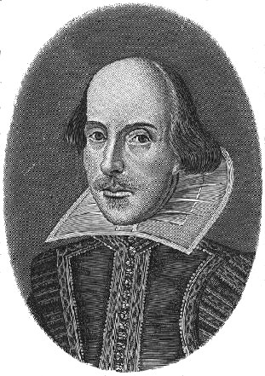
He is the most famous writer in the world, but he left us no journals or letters – he left us only his poems and his plays. What we know about William Shakespeare’s personal life comes mostly from church and legal documents – a baptismal registration, marriage license, and records of real estate transactions. We also have a few remarks that others wrote about him during his lifetime.

We know that William was born the third of eight children around April 23, 1564, in Stratford, a market town about one hundred miles northwest of London. His father, John, was a shoemaker and a man of some importance in Stratford, serving at various times as justice of the peace and high bailiff (mayor).

William attended grammar school, where he studied Latin grammar, Latin literature, and rhetoric (the uses of language). As far as we know, he had no further formal education.

At the age of eighteen, he married Anne Hathaway, who was eight years older than he was. Sometime after the birth of their second and third children (twins), Shakespeare moved to London, apparently leaving his family in Stratford.

We know that several years later, by 1592, Shakespeare had already become an actor and playwright. By 1594, he was a charter member of the theatrical company called the Lord Chamberlain’s Men, which was later to become the King’s Men. As the names of these acting companies indicate, theatrical groups depended on the support of a wealthy patron—the King’s Men were supported by King James himself. Shakespeare worked with this company for the rest of his writing life. Year after year he provided it with plays, almost on demand. Shakespeare was the ultimate professional writer. He had a theater that needed plays, actors who needed parts, and a family that needed to be fed.
Romeo and Juliet was probably among the early plays that Shakespeare wrote, between 1594 and 1596. By 1612, when he returned to Stratford to live the life of a prosperous retired gentleman, Shakespeare had written thirty-seven plays, including such masterpieces as Julius Caesar, Hamlet, Othello, King Lear, and Macbeth.

Shakespeare’s plays are still produced all over the world. During a Broadway season in the 1980’s, one critic estimated that if Shakespeare were alive, he would be receiving $25,000 a week in royalties for a production of Othello alone. The play was attracting larger audiences than any other nonmusical production in town.

Shakespeare died on April 23, 1616, at the age of fifty-two. He is buried under the old stone floor in the chancel of Holy Trinity Church in Stratford. Carved over his grave is the following verse (the spelling has been modernized):

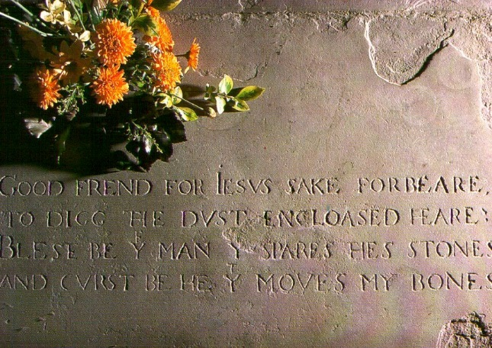

Good friend, for Jesus’ sake forbear
To dig the dust enclosed hear!
Blessed be the man that spares these stones
And cursed be he that moves my bones.

These are hardly the best of Shakespeare’s lines (if indeed they are his at all), but like his other lines, they seem to have worked. His bones have lain undisturbed to this day.

